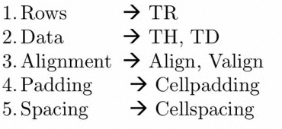

border="1"

align="left"

width="400" or width=”50%”

cellspacing="0" thickness of borders

cellpadding="2" the space between context and border

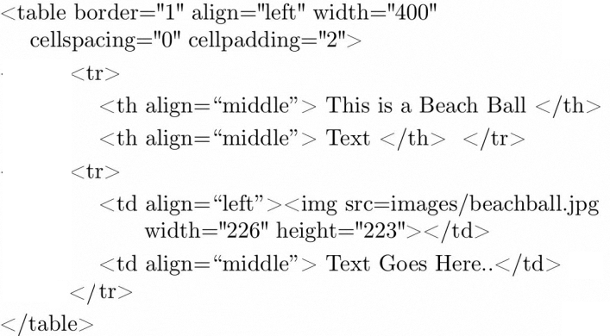

|  |  |
| --- | --- |
| HTML4 | HTML5 |
|  |  |

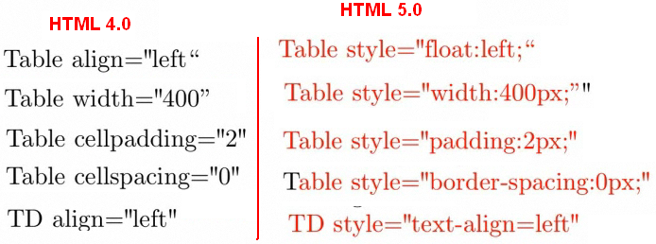

WWW.quackit.com

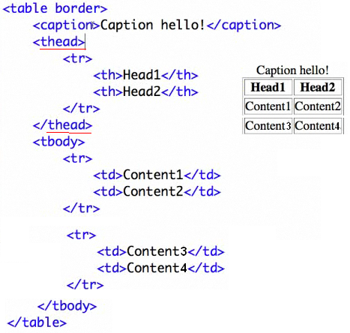

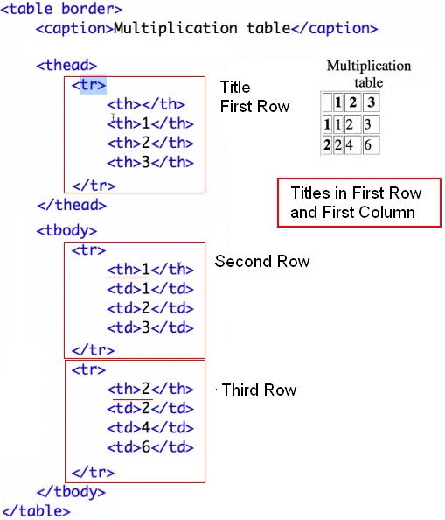

DIVISION PARA USARLA CON UN CONTROL

<div style="width: 505px; left: 176px; width: 1100px; position: absolute;

top: 260px; height: 24px">

<asp:Table ID="**Table1**" runat="server"></asp:Table>

</div>

TABLAS

<asp:Table ID="Table1" runat="server" Height="66px" HorizontalAlign="Center"

Width="950px">

<asp:TableRow ID="TableRowa1" runat="server">

<asp:TableCell ID="TableCella1" runat="server">

<asp:Image ID="Fotos" runat="server" Height="100px" Width="100px" />

</asp:TableCell>

<asp:TableCell ID="TableCeeell2" runat="server">

<asp:Label ID="EMPLOYEE" runat="server" Width="255px"

Font-Bold="True" ForeColor="Maroon" ></asp:Label>

</asp:TableCell>

</asp:TableRow>

</asp:Table>

<asp:Table ID="Table2" runat="server" HorizontalAlign="Center" Height="64px" Width="950px">

<asp:TableRow ID="TableRow2" runat="server">

<asp:TableCell ID="TableCell5" runat="server">Reported&nbsp;&nbsp;

<asp:Label ID="Date1" runat="server" Font-Underline="True" Width="150px"

Font-Bold="True" ForeColor="Maroon" ></asp:Label>

</asp:TableCell>

<asp:TableCell ID="TableCell6" runat="server">Incident&nbsp;&nbsp;

<asp:Label ID="Date2" runat="server" Font-Underline="True" Width="150px"

Font-Bold="True" ForeColor="Maroon" ></asp:Label>

</asp:TableCell>

<asp:TableCell ID="TableCell1" runat="server">Source&nbsp;

<asp:Label ID="ReportedBy" runat="server" Font-Underline="True"

Width="150px" Font-Bold="True" ForeColor="Maroon" ></asp:Label>

</asp:TableCell>

</asp:TableRow>

</asp:Table>

<asp:Label ID="Label3" runat="server" Font-Bold="True"

Font-Underline="True" ForeColor="Maroon"

Style="z-index: 101; left: 162px; position: absolute; top: 220px"

Text="Choose the Language">

</asp:Label>

&nbsp; &nbsp; &nbsp; &nbsp; &nbsp; &nbsp; &nbsp;

<asp:DropDownList ID="Language" runat="server" Width="112px"> </asp:DropDownList>

<asp:ImageButton ID="ImageButton1" runat="server"

Height="38px" ImageUrl="~/button_report.gif"

OnClick="ImageButton1_Click" Width="86px" />

<asp:Table ID="Table1"

Style="z-index: 101; left: 170px; position: absolute; top: 285px"

runat="server">

</asp:Table>